3. What facilities does it have? Are there any student activities or clubs?

Foreign Trade University (FTU) offers modern facilities designed to support academic learning and student life across its campuses. Classrooms and Lecture Halls: Equipped with modern teaching tools and comfortable seating, designed to enhance the learning experience.

Library with a resource center for academic materials and research.

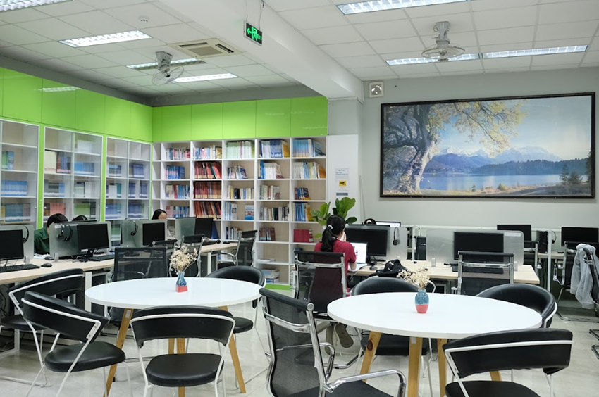

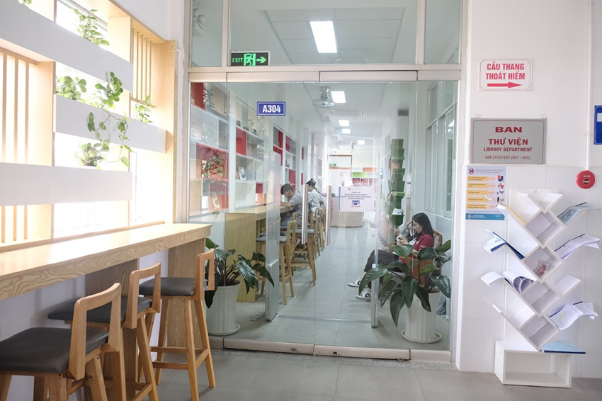

Computer Rooms with the equipped with modern technology for student use.

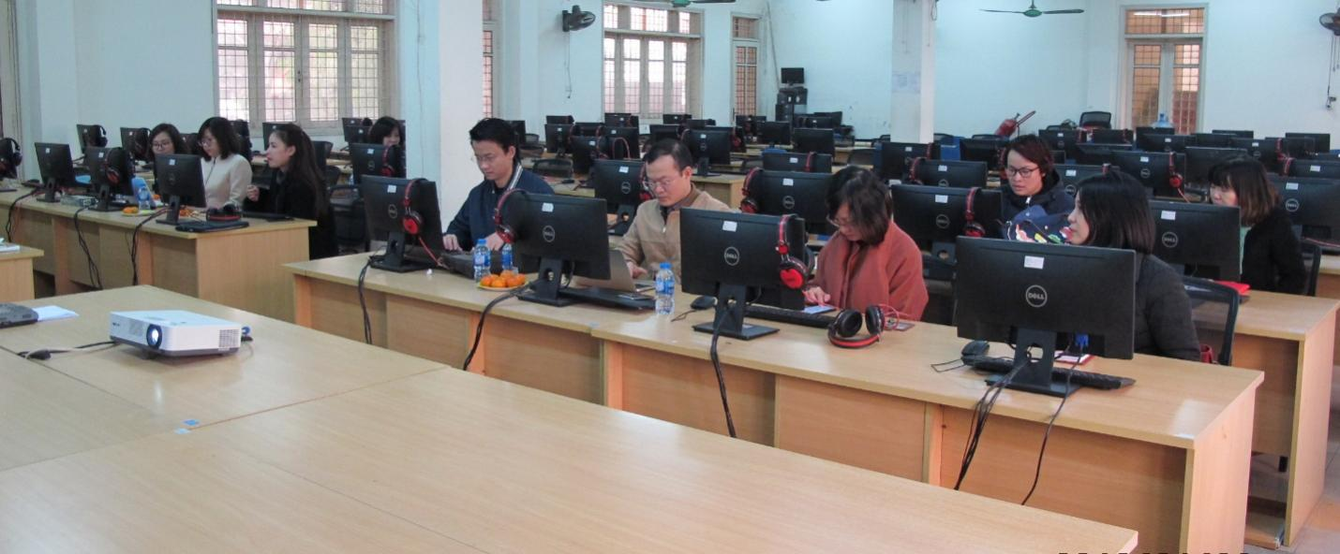

Vietnam-Japan Human Resources Cooperation Center (VJCC) with a venue for international seminars and conferences. 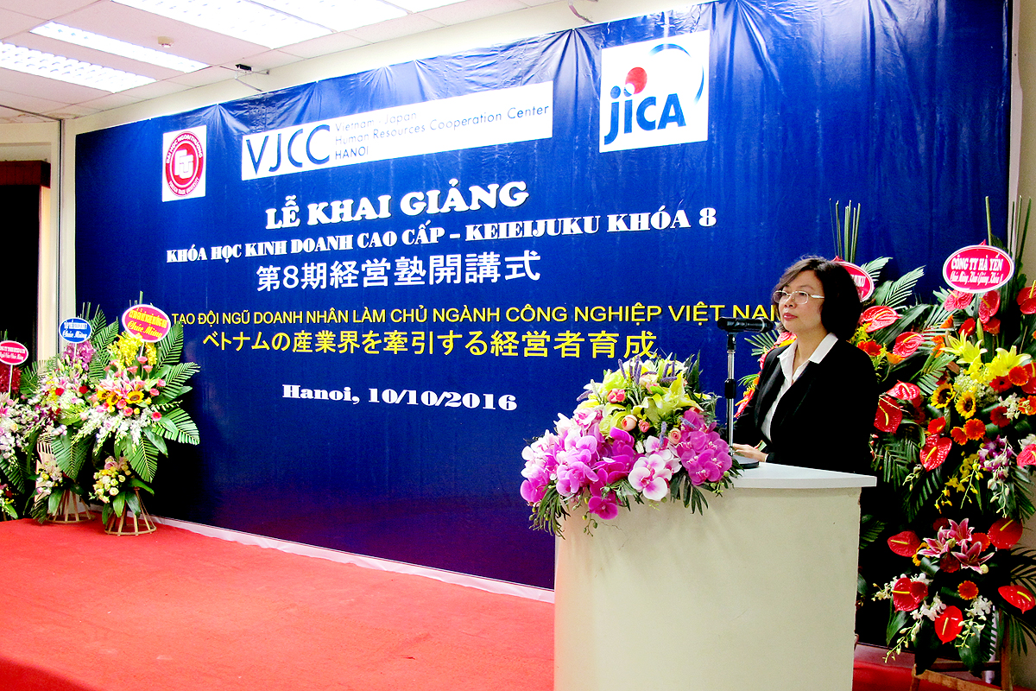

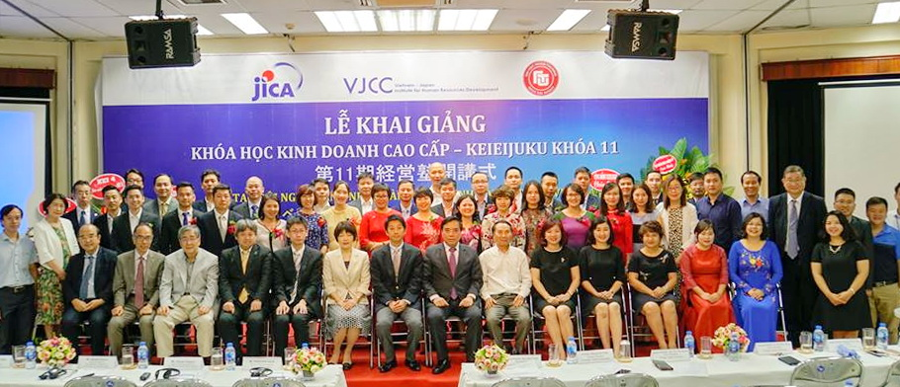

In addition, there are clubs for students. English Club (E-Club): This club is where students can practice English skills, communicate, and participate in extracurricular activities related to international languages ​​and cultures. Art Club: For students who love creative and artistic activities such as drawing, dancing, music... And besides, there is also a student festival to give students the opportunity to participate in exchange activities with all students from other schools.

1. What job opportunities are there for its students after graduation?

After graduating with a degree in foreign economics, you will have many job opportunities in the domestic and global markets.They can pursue roles as International Trade Specialists, where they manage cross-border trade activities and ensure compliance with regulations or working in government agencies, embassies or focusing on international policy diplomacy and trade negotiations. Other opportunities include becoming International Marketing Managers, developing global marketing strategies for multinational companies.Those job opportunities will help you practice more skills in life.